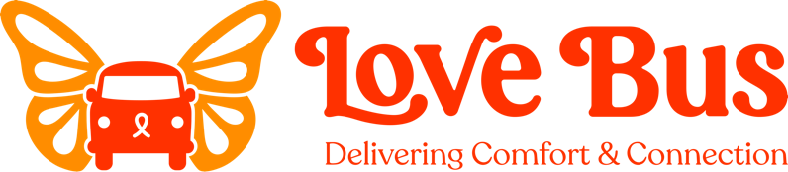

Please present to your child’s oncologist or NP on their medical team; children in remission for more than one year may present to their attending physician for therapies other than those italicized below.

Love Bus Medical Permission Form
Dear Medical Professional,

Your patent, ___________________________, has applied for a monetary grant for integrative therapies through our non-profit organization, Love Bus (www. LoveBus.org). Prior to providing services to pediatric oncology patents, we require medical permission from the parent’s primary oncologist or nurse practitioner (or family physician for those at least one year in remission).

Please check the therapies that you approve for the above pa4ent. Please make a note of any contraindications.

- ALL THERAPIES LISTED BELOW
- Acupuncture
- Acupressure (no needles)
- Aromatherapy/essential oils
- Art therapy or lessons
- Child life support or play therapy
- Chiropractic care
- Craniosacral/myofascial therapy
- Dance
- Ferity preservation
- Gym membership or personal training
- Gymnastics
- Martial arts
- Mediation
- Music therapy or lessons
- Naturopathy or herbal supplements
- Notional counseling
- Oncology massage (only from a licensed therapist with oncology certification)
- Massage (from a licensed therapist, may not have oncology OR pediatric experience) ¨ Reflexology
- Reiki/Tong Ren/ Other Energy Work
- Swimming/aquatic therapy
- Therapeutic horseback riding/hippotherapy
- Regular horseback riding lessons at a facility that does NOT have PATH certification
- Yoga
- Other: ________________________________

Oncologist’s signature: _____________________________ Date: ________________

Printed name: _____________________________________ Phone/email: _______________________

Please fax to: (978) 517-1567; Questions: (781) 454-8535 or Kerry@LoveBus.org

